

**Project Name**: **Med Easy** Making clinic operations effortless and efficient for both staff and patients. (Clinic Management System)

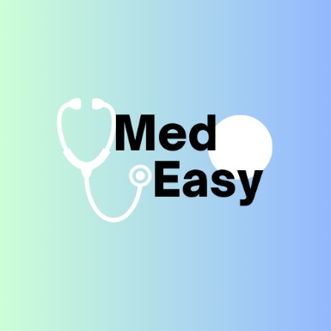**By: Yousef Afif**

**Ali Srour**

**To The instructor (s) :**

Dr. Ibrahim Dhaini

Dr. Yasser Fadallah

Dr. Ahmad Fadallah

And every software engineer/enthusiast in this university

**Table of contents**

**1- Introduction**

1.1 Product scope

1.2 Product value

1.3 Intended audience

1.4 Intended use

1.5 General description

**2- Functional requirements**

**3- External interface requirements**

3.1 User interface requirements

3.2 Hardware interface requirements

3.3 Software interface requirements

3.4 Communication interface requirements

**4- Non-functional requirements**

4.1 Security

4.2 Capacity

4.3 Compatibility

4.4 Reliability

4.5 Scalability

4.6 Maintainability

4.7 Usability

4.8 Other non-functional requirements

**System Model**

In the process of engineering the MedEasy project, we have chosen the **AGILE SDLC** model. This model is highly flexible, adaptable, and incremental, enabling us to deliver a functional product as soon as possible. Furthermore, Agile allows for seamless adaptation to changes in user requirements, avoiding costly rework. For example, if the initial requirement was to create a clinic management system for in-person operations only, but later it needs to support telemedicine consultations or remote patient monitoring, Agile allows for incorporating these changes smoothly. Additionally, the strong customer-vendor collaboration ensures customer satisfaction, fostering a customer-centric relationship and building an excellent reputation in the healthcare technology industry.

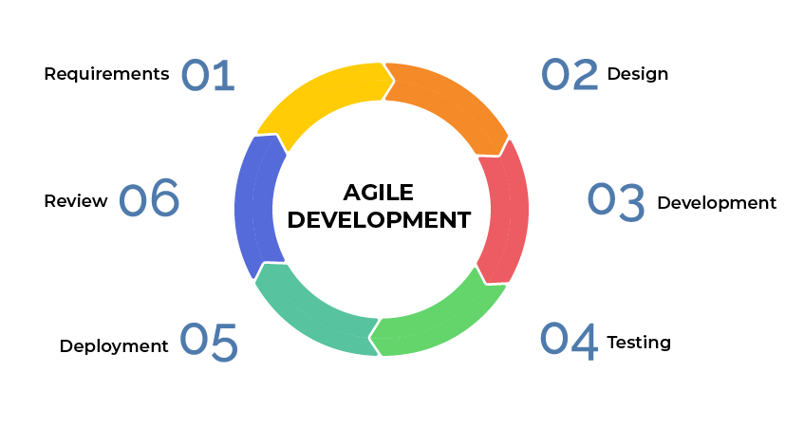

**The purpose of the documents**

This SRS describes the software project **MedEasy** , which is a smart and automated Clinic Management System (CMS). Its main purpose is to streamline clinic operations, making them effortless and efficient for both staff and patients. By automating administrative tasks, managing patient records, scheduling appointments, and providing real-time insights, MedEasy aims to enhance the overall efficiency and quality of healthcare services.

# Introduction

|  |  |
| --- | --- |
| **1.1 Product Scope** | |
| * **Benefits** * **Improved Accuracy:**   **Reduce errors and inaccuracies associated with manual record-keeping and appointment scheduling, leading to more reliable data.**   * **Time Saving:**   **Automate time-consuming tasks such as patient registration, billing, inventory management, and report generation, freeing up clinic staff for more critical activities.**   * **Cost Efficiency:**   **Optimize resource utilization and minimize costs associated with administrative overhead, missed appointments, and inefficient workflows.**   * **Enhanced Compliance:**   **Ensure compliance with healthcare regulations, data privacy laws (e.g., HIPAA), and internal policies related to patient management.**   * **Increased Productivity:**   **Streamline processes and eliminate bottlenecks, allowing staff to focus on delivering better patient care.**   * **Better Decision-Making:**   **Access real-time data and analytics to make informed decisions related to resource allocation, staff scheduling, and operational planning.**   * **Objective and Goals:**  1. **Automation:**   **Reduce manual intervention in clinic operations by automating routine tasks such as patient registration, appointment scheduling, and billing.**   1. **Accuracy:**   **Improve the accuracy and reliability of patient records, appointment schedules, and financial transactions through automated validation checks.**   1. **Efficiency:**   **Increase operational efficiency by streamlining clinic workflows, minimizing administrative overhead, and reducing time spent on repetitive tasks.**   1. **Compliance:**   **Ensure compliance with legal and regulatory requirements, as well as internal policies and procedures related to healthcare management.**   1. **User Satisfaction:**   **Enhance user satisfaction among clinic staff, doctors, and patients by providing a user-friendly interface, intuitive features, and responsive support.**   1. **Data Insights:**   **Enable data-driven decision-making by providing comprehensive reports, analytics, and insights on patient trends, clinic performance, and resource utilization.** |
| **1.1.2 Feasibility study** | |
| **The feasibility study is one of the most important steps in the development of any software. It assesses how practical and viable our project is based on several criteria:**  **Technical Feasibility:**  **This part evaluates whether the proposed MedEasy system can be developed using the available technology and resources. It examines factors such as:**   * **Compatibility of hardware and software components.** * **Availability of required expertise in healthcare software development.** * **Feasibility of implementing desired features within the Agile SDLC framework.**   **For MedEasy , the technical feasibility is high. The system can be implemented efficiently by selecting appropriate technologies:**   * **Database Type: SQL (for structured data like patient records) or NoSQL (for unstructured data like medical images).** * **Backend Frameworks: Enterprise frameworks like Django (Python) or .NET are preferred due to their scalability and robustness.** * **Frontend Frameworks: Modern frameworks like React.js or Angular can be used to build a responsive and intuitive user interface.**   **Economic Feasibility:**  **This analysis focuses on the cost-effectiveness of developing and running the MedEasy system. It estimates:**   * **Development costs (e.g., hiring developers, purchasing tools/licenses).** * **Ongoing maintenance expenses (e.g., server hosting, updates).** * **Potential savings or revenue generated through improved efficiency and productivity.**   **For MedEasy , the economic feasibility is favorable:**   * **Development costs are manageable due to the availability of open-source tools and lightweight frameworks.** * **The system can generate significant savings by reducing administrative overhead and improving clinic efficiency.** * **Long-term benefits (e.g., increased patient satisfaction, reduced operational costs) outweigh initial development costs.**   **Legal Feasibility:**  **This analysis ensures that the proposed system complies with all applicable laws and regulations. Key considerations include:**   * **Data Privacy Laws: Compliance with regulations like HIPAA (Health Insurance Portability and Accountability Act) or GDPR (General Data Protection Regulation) for patient data protection.** * **Licensing Requirements: Ensuring that the software meets any licensing or certification requirements for healthcare systems.**   **For MedEasy , the legal feasibility is strong:**   * **The core functionality of the system (clinic management) is entirely legal and aligns with healthcare regulations.** * **Proper measures will be implemented to ensure data security and privacy compliance.** | |
| **1.2 Product value** | |
| **The MedEasy Clinic Management System is designed to deliver transformative value to healthcare providers and patients alike. By addressing key pain points in traditional clinic operations, the system enhances patient care, streamlines administrative tasks, and ensures secure, accurate, and timely access to medical records** |
| **1.3 Intended audience** | |
| **The MedEasy Clinic Management System is designed to cater to a diverse target audience, each with unique needs and expectations. By addressing the specific pain points of healthcare providers , clinic administrators , and patients , MedEasy ensures that its solution is comprehensive, user-friendly, and impactful** |
| **1.4 Intended use** | |
| **The MedEasy Clinic Management System is specifically designed to assist clinic staff in managing three critical aspects of clinic operations: patient appointments , medical records , and billing procedures . By addressing these core functions, the system ensures that clinics operate more efficiently, reduce errors, and enhance the overall patient experience.** |
| **1.5 General description** | |
| **The MedEasy Clinic Management System is designed to streamline and enhance clinic operations through its core modules: Patient Management , Appointment Scheduling , Billing Management , and Reporting . Each module plays a critical role in improving operational efficiency for clinic staff and enhancing the overall patient experience** |

**2. Functional Requirements**

* **Patient Management**: Create, update, and retrieve patient records.
* **Appointment Scheduling**: Enable patients to book, reschedule, or cancel appointments.
* **Billing Management**: Generate invoices and process payments efficiently.
* **Reporting**: Provide analytical reports on patient visits and billing activities.

**3. External Interface Requirements**

**3.1 User Interface Requirements**

* An intuitive and user-friendly interface accessible on various devices.
* An admin dashboard for managing clinic operations.
* A patient portal for viewing health information and appointment details.

**3.2 Hardware Interface Requirements**

* Compatibility with standard desktop and mobile devices.
* Optional integration with biometric devices for patient check-in.

**3.3 Software Interface Requirements**

* A web-based application compatible with major web browsers.
* Integration capabilities with third-party billing and insurance systems.

**3.4 Communication Interface Requirements**

* Secure data transmission using HTTPS.
* API support for integration with other healthcare systems.

**4. Non-Functional Requirements**

**4.1 Security**

* Implement robust user authentication and role-based access controls.
* Encrypt sensitive patient information to ensure data confidentiality.

**4.2 Capacity**

* The system should support a growing number of users and data without performance loss.

**4.3 Compatibility**

* Ensure compatibility with various operating systems and devices to maximize accessibility.

**4.4 Reliability**

* Achieve a system uptime of 99.9% to ensure continuous availability for users.

**4.5 Scalability**

* Design the system to handle increased loads and user counts as the clinic grows.

**4.6 Maintainability**

* Facilitate easy updates and maintenance to adapt to changing healthcare regulations and technologies.

**4.7 Usability**

* Ensure the system is easy to navigate, minimizing training time for users.

**4.8 Other Non-Functional Requirements**

* Address performance benchmarks for response times and system efficiency.
* Ensure accessibility for users with disabilities, complying with relevant standards.

# Definitions and acronyms

|  |  |
| --- | --- |
| MedEasy | MedEasy is a Clinic Management System (CMS) designed to streamline clinic operations,  making them effortless and efficient for both staff and patients.  It automates tasks like appointment scheduling, billing, and medical record management. |
| CMS (Clinic Management System) | A CMS is a software solution that helps clinics manage various operational tasks  such as patient registration, appointment scheduling, billing,  and reporting to improve efficiency and patient care. |
| EHR (Electronic Health Record) | EHR is a digital version of a patient’s medical history, including diagnoses, medications,  treatment plans, and test results. MedEasy uses EHR to centralize and secure patient data. |
| HIPAA (Health Insurance Portability and Accountability Act) | HIPAA is a U.S. law that sets standards for protecting sensitive patient health information.  MedEasy ensures compliance with HIPAA to safeguard patient data privacy. |
| GDPR (General Data Protection Regulation) | GDPR is a European Union regulation that governs data protection and privacy.  MedEasy adheres to GDPR principles to ensure secure handling of patient data globally. |
| MTBF (Mean Time Between Failures) | MTBF is a reliability metric representing the average time a system or component operates  before experiencing a failure. MedEasy aims for high MTBF to ensure system stability and  minimize downtime. |
| Agile SDLC | Agile SDLC is a software development lifecycle model chosen for MedEasy.  It emphasizes flexibility, adaptability, and incremental delivery, allowing seamless  adaptation to changes in user requirements. |
| SQL (Structured Query Language) | SQL is a domain-specific language used for managing and querying relational databases.  MedEasy uses SQL-based databases to store and retrieve patient records,  appointment schedules, and billing data. |
| NoSQL | NoSQL refers to non-relational databases that handle unstructured or semi-structured data.  MedEasy may use NoSQL databases for storing large-scale imaging data or logs efficiently. |
| API (Application Programming Interface) | An API is a set of protocols and tools for building software applications.  MedEasy provides APIs for integrating third-party services like insurance providers or  telemedicine platforms. |
| RESTful API | A RESTful API is an architectural style for designing networked applications using standard  HTTP methods. MedEasy’s APIs adhere to REST principles for seamless integration  with external systems. |
| HTTPS (Hypertext Transfer Protocol Secure) | HTTPS is an extension of HTTP designed for secure communication over the internet.  MedEasy uses HTTPS to encrypt sensitive patient data during transmission,  ensuring confidentiality and integrity. |
| UI/UX (User Interface/User Experience) | UI/UX focuses on designing intuitive and engaging interfaces.  MedEasy prioritizes UI/UX to enhance the experience of both clinic staff and patients. |
| CI (Continuous Integration) | CI is a software development practice where code changes are automatically built, tested,  and integrated into a shared repository frequently. MedEasy uses CI to detect and address  integration issues early. |
| Bootstrap | Bootstrap is a popular CSS framework used in MedEasy for creating consistent  and responsive layouts for clinic dashboards and patient portals. |
| Tailwind CSS | Tailwind CSS is a utility-first CSS framework used in MedEasy for flexible and customizable  styling without writing custom CSS. |
| jQuery | jQuery is a lightweight JavaScript library used in MedEasy for simplifying DOM manipulation,  event handling, and AJAX requests. |
| Telemedicine | Telemedicine refers to remote healthcare services delivered via video calls or messaging.  MedEasy integrates telemedicine features to enable virtual consultations for patients. |
| KPI (Key Performance Indicator) | KPIs are metrics used to evaluate the performance of MedEasy, such as patient footfall,  revenue trends, appointment cancellations, and staff productivity. |
| OCR (Optical Character Recognition) | OCR technology is used in MedEasy to digitize paper-based medical records by  converting scanned documents into editable text. |

Class Diagram

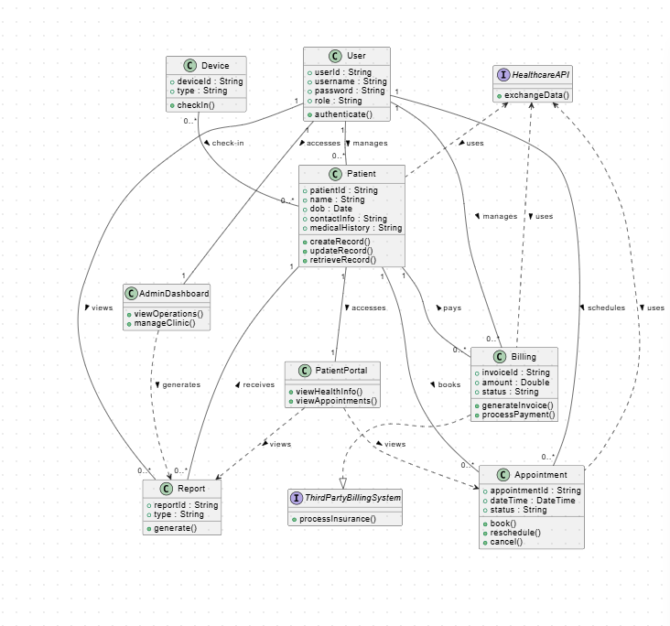

Activity Diagram

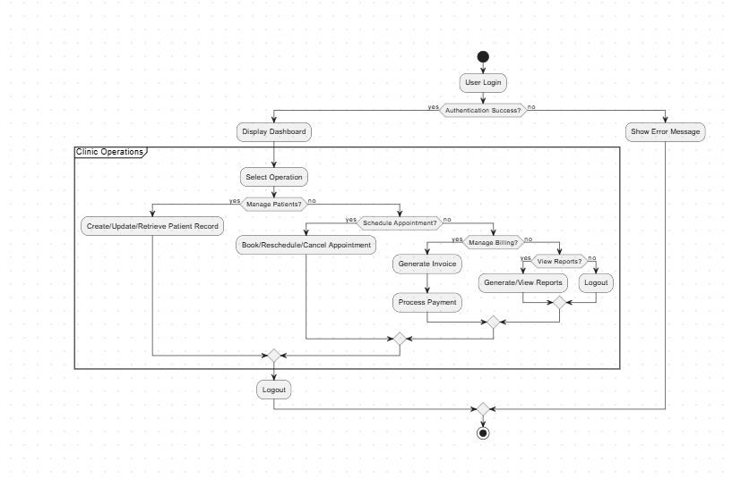

Use Case Diagram

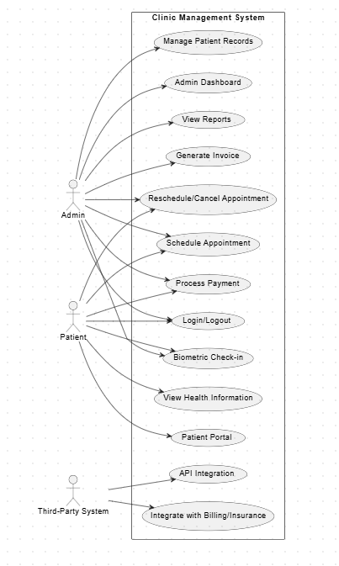

Data Flow

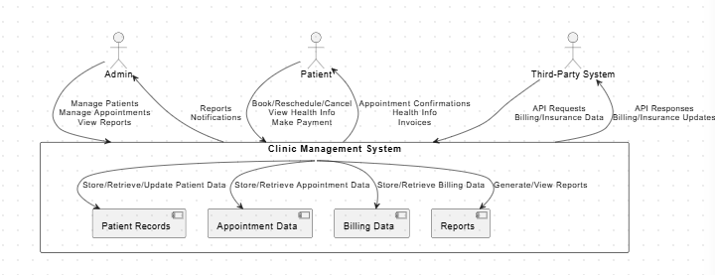

Extracted Tasks and Subtasks

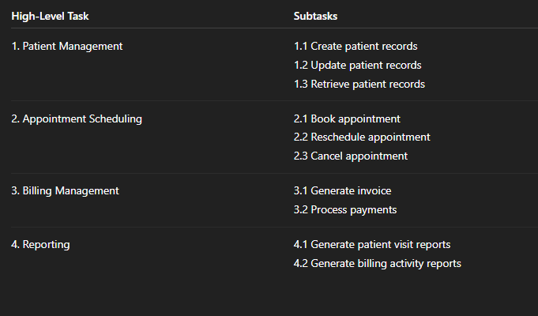

Project Scheduling Table

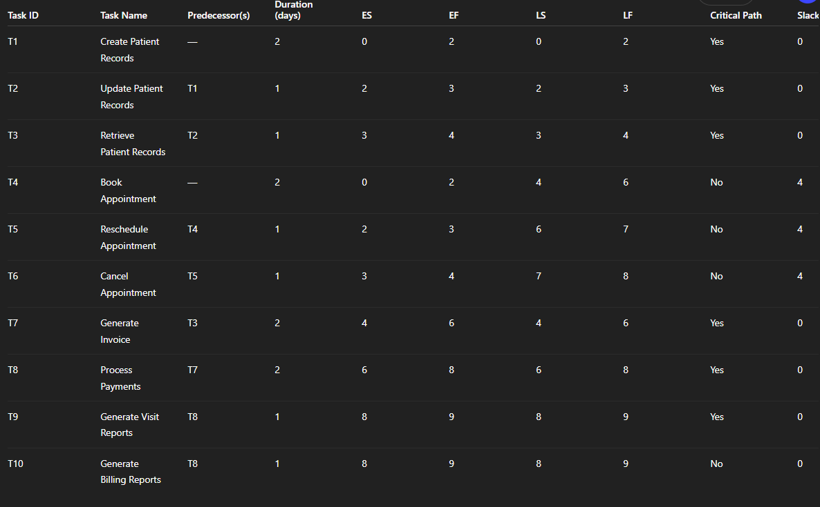

Pert Chart

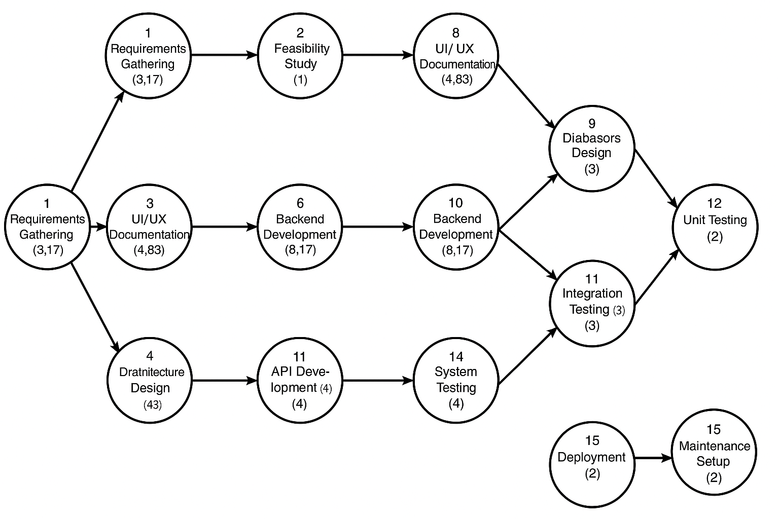

Gantt Chart

